
YEAR 12 CHEMISTRY – 3BCHE

SEMESTER 2

LAB THEORY TEST 2

Organic Chemistry – Experiment 25 & 26

Recommended time: 1 hour

/ 20

ANSWERS

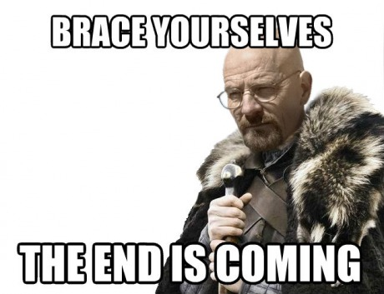

Laboratory Test: Alcohols and Esters (20 marks)

Answer the following questions based on Experiments 25 and 26

1. (a) orange to green (1 mark)

(b) purple to pale pink (1 mark)

2. (a)

Reactant | Structural formula of product | IUPAC name of product
ethanol | 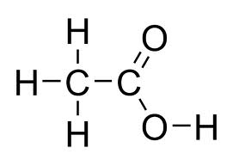  (1) | (1)  Ethanoic acid
butan-2-ol | 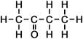  (1) | (1)  Butanone
2-methylpropan-2-ol | No product (1/2) | No product (1/2)

(b) 5CH₃CH₂CH₂CH₂OH + 4MnO₄⁻ + 12H⁺ → 5CH₃CH₂CH₂COOH + 4Mn²⁺ + 11H₂O (3 marks)

(c) permanganate solution changes from purple to pale pink (1 mark)

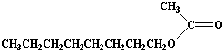
- (a) (1 mark)

- catalyse the reaction (1 mark)

- H₂O (1 mark)

  (1 mark) | 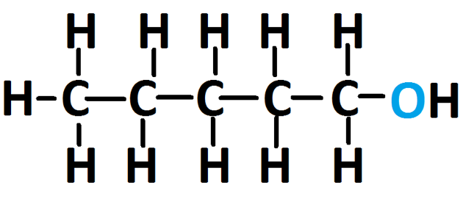  (1 mark)

- (a) H₂SO₄ is required to create an acidified KMnO₄ solution without which reduction of MnO₄⁻ can not occur. (1 mark)

- The rate of reaction is slow at room temperature (1 mark)

(c) i. H₂SO₄ is corrosive – handle with care ii. Alcohols are volatile & flammable – avoid open flame.
(2 marks)

